Hardware: Input
hw_input.php — Hardware

Input
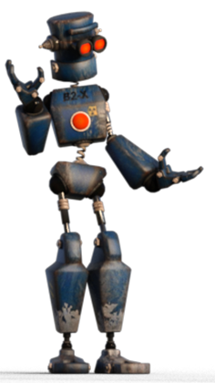

Getting data and instructions / commands into the computer
To work with a computer we have to be able to tell it what to do - and to give it data to work on. To do this we need some way of providing the computer with input.
In this section we take a quick look at the most common input devices and how they work
Before you get started:
Can you remember the cycle that all computers follow when they work? The IPO cycle. This cycle starts with the computer getting data to work with - and instructions / commands that tell it what to do with the data.
Can you remember the difference between instructions and commands (from the Basic Concepts module)?
Instructions:
Code that tells the computer what to do - e.g. a program
Commands:
When the user clicks a menu option / button to tell the computer what specific set of instructions to follow.
Use the dropdowns below to explore the different types of input devices we use with our computers.
Keyboard

The keyboard
Before the Keyboard
Punch Card
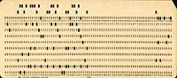
By Pete Birkinshaw from Manchester, UK (Used Punchcard) [CC BY 2.0 ], via Wikimedia Commons
Punch Tape
[image unavailable: Stacks Image 5425]
By TedColes [Public domain], from Wikimedia Commons
They keyboard was the first direct way of giving input to the computer.
Before the keyboard you had to either flip switches on the computer, plug in cables into something that looked like a switchboard.
Later on you would have to punch holes into cards or paper tape. You would do this without having access to the computer. You would then send your punched cards or tape to the computer room where your program and data would be loaded from the punched card / tape. The computer would run the program and print out your results.
Finally your results would be sent back to you - all of this happening without you seeing or touching the computer!
The keyboard was a miracle. It allowed you to type commands directly into the computer - and it would usually respond by printing something on a teletype printer.
Only when the screen became common place did computers become more interactive and user friendly, allowing you to type on the keyboard and see what you were typing - and the computer's response on the screen in text.
All about the Keyboard
The computer keyboard simply inherited and used the keyboard designs used by typewriters at the time.
Besides some ergonomic designs and the addition of keys for functions, controlling the cursor position, media control and a numeric keypad for those who do a lot of work with numbers - not much has changed in keyboards for the last 140 years or so!
[image unavailable: Stacks Image 5429]

Special Keys & what they do
Function Keys

Shortcuts to common commands
[image unavailable: Stacks Image 5432]
The top row of your keyboard is taken up by function keys. These keys were incredibly important before the GUI - they represented common commands in programs - e.g. F1 to display Help, F2 to save a file, etc.
Each program could decide what command it would link to a function key - so you had to learn the specific use of the function keys for the program you were using.
This is still true today - but because of our GUI and mouse focussed computing function keys are used far less often they they used to be.
Back to the top of this Panel
Arrow (Cursor) Keys

Moving the text cursor around
[image unavailable: Stacks Image 5435]
The arrow keys on the keyboard are used to move the cursor around when typing text.
They can also be used for fine positioning of items in graphics, photo editing, presentation and other software.
Your OS usually also has a setting that allows you to use these keys to control the mouse pointer for in case your mouse malfunctions (or the batteries die in a wireless mouse).
This function is called Mouse Keys and in Windows you turn it on in the Ease of Access section of the control panel / PC settings.
When turned on, Mouse Keys allows you to use the arrow keys in the numerical keyboard part of your extended keyboard to control the mouse.
If you have turned on mouse keys and it does not seem to be working, press the Numlock key - this will toggle the numerical keyboard between numbers and arrow functions.
Back to the top of this Panel
Additional Keys

Ctrl, Alt, Home, Pg-Up, Pg-Down, etc.
[image unavailable: Stacks Image 5438]
Your keyboard contains a lot of additional keys besides the alphabetic, numerical, function and arrow keys.
Some of these keys are useful to know and use. Some are no longer used.
These extended keys are explained below:
[image unavailable: Stacks Image 5441]
These are modifier keys. Holding them down whilst pressing a different key (or when clicking the mouse) gives the key or the mouse click an alternative meaning.
Typically they are used with other keys to create shortcuts. For example many programs use Alt-S to save a file. Ctrl-C is the shortcut forCopy, Ctrl-X is the shortcut for
Cut
and
Ctrl-V
is the shortcut for
Paste
.
Hints to these shortcuts are displayed next to the commands they are used for in the menus of the program. Also, many programs have a status bar at the bottom of their window. That status bar cab often tell you how using a modifier key will change what clicking your mouse does!
To learn to use a computer efficiently, read the screen! Read all parts of the screen and think about the clues and hints you are being given about what to do!
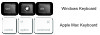
Alt, Ctrl & the Windows Key:
[image unavailable: Stacks Image 5444]
The Fn key originally appeared only on laptops - and on Apple keyboards.
It is used to change what the Function keys (the top row of the keyboard) do.
Using the Fn key with a Function key will do things like play or pause media, increase and decrease volume, etc.
These alternative functions are displayed on the F keys themselves.
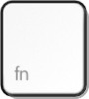
Fn
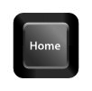
This key takes you to the beginning of a line of text.
Pressing a modifier key whilst using Home can take you to the beginning of the paragraph or even the top of the document - depending on the program you are using.
Home
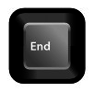
This key takes you to the end of a line of text.
Pressing a modifier key whilst using End can take you to the end of the paragraph or even the bottom (end) of the document -depending on the program you are using.
End

This key normally scrolls you up one page in a text document.
Useful in Word-processing and on long web pages.
Page Up

This key normally scrolls you down one page in a text document.
Useful in Word-processing and on long web pages.
Page Down
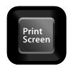
This key originally was used to copy what was on your screen to the printer (before the days of DOS).
The key was really popular when there was no option to print a document - the only way to get a hard copy was to print what was on the screen.
This key is now set to capture an image of the screen.
Print Screen
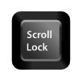
This key was used to stop the arrow keys and the pg-up, pg-down keys from making text scroll in the days of DOS. It is not used for anything anymore.
You can usually use settings in your OS to re-program it to do anything you want.
Scroll Lock
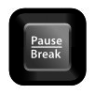
This key was used to stop a program running - especially a BASIC program.
It is no longer used.
You can usually use settings in your OS to re-program it to do anything you want.
Break / Pause
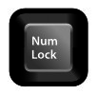
Num Lock toggles the numerical keyboard between control mode (the keys act as arrow keys, pg-up, pg-down, etc.) and numerical mode (the keys act as numbers and maths operators).
Num Lock
Back to the top of this Panel
QWERTY

The arrangement of keys on the keyboard
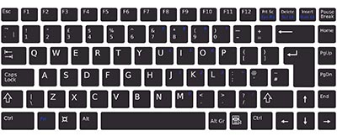
Keyboards are often called QWERTY keyboards
This simply refers to the order of the letters on the top alphabetic row on the keyboard.
The keys are in this order because this is what a typewriter keyboard looked like - and creators of computers wanted to stick to the familiar layout.
This is not the only layout there is. The French for example use an AZERTY keyboard. The DVORAK keyboard is another alternative (but this is named after its inventor, not the order of the keys).
Even QWERTY keyboards are not all standard as American keyboards and European / UK keyboards put different symbols on different keys.
This video is a bit of a rant on why QWERTY is overrated….
Back to the top of this Panel
Keyboard Alternatives

No keyboard - No problem
The keyboard is not the only way of inputting text.
Mobile devices generally do not have a physical keyboard. They use an on screen virtual keyboard that pops up on the screen when you need to input text.
If you don't like using the keyboard, type slowly or just want to try something different, here are some alternatives to keyboards for entering data and controlling your computer:
You can try voice recognition (discussed under Microphones) or OCR (discussed under Scanners & Cameras).
Gamers prefer game controllers for general input: e.g. joysticks, steering wheels and control pads (discussed under Game Controllers).
The disabled might use eye-tracking or head tracking (discussed under Input for the disabled).
Back to the top of this Panel
Back to the top of the Dropdown List
Mouse

The Mouse
Origins of the mouse
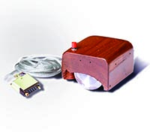
By SRI International (SRI International) [GFDL or CC BY-SA 3.0 ], via Wikimedia Commons
Douglas Englebart invented the mouse in 1965. It was a wooden box with two rotating wheels and could only be moved either up and down or from side to side - diagonal motion was not possible.
The mouse only became something that people sat up and paid attention to in the mid 1980's when Apple introduced it with the GUI interface in its Lisa and Macintosh computers.
Windows 3.1 (1991) made the GUI the default interface for most computer users - and since then the mouse has been the main way that we interact with computers.
The alternative to a mouse for users of mobile devices is the touchscreen. Here you touch what you would click on. You also use gestures (swipe, pinch, etc.) to perform additional commands not possible with a mouse.
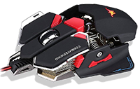
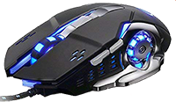
Since then the mouse has:
moved from 1 to 3 buttons (the scroll wheel in the middle can be used as a button),
a (usually clickable) scroll wheel has been added to make it easier to scroll through documents and web pages and
the mouse no longer uses a rolling ball to detect your movements but rather measures changes in light reflected off the surface you are using it on.
Gamers may spend more money to buy a high precision mouse that uses lasers instead of LEDs as a light source and which has less lag (meaning a faster response).
A Gaming mouse also has additional buttons to give the gamer extra controls - and, just for the look of it, RGB LED lighting to add that necessary funkiness…

Tips for working with a mouse

Connecting a mouse
Any new mouse will usually connect to the computer using:
(click the heading to toggle the display of information…)
USB

The mouse can plug into any USB port on the computer.
If your computer has USB 2 and USB 3 then rather use a USB 2 port for the mouse because it does not need the speed of USB 3 - save one of those ports for something that needs the speed (like an external hard drive)!
Bluetooth
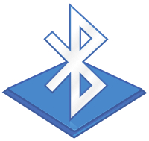
If the mouse is Bluetooth then make sure your computer has Bluetooth (most laptops do, most PC desktops don't whilst Apple desktops do.
If the computer doesn't have bluetooth you can buy a USB Bluetooth dongle to plug into a USB port.
With a Bluetooth mouse you will have to pair the mouse with your computer. This usually involves putting the mouse in 'pairing mode' then opening the Bluetooth setup on the computer, finding the mouse on the list of devices and choosing the 'pair' or 'connect' option.
Wireless

If you have a WiFi mouse then the wireless dongle that comes with the mouse will plug into a USB port.
If your computer has USB 2 and USB 3 then rather use a USB 2 port for the mouse because it does not need the speed of USB 3 - save one of those ports for something that needs the speed!
With the WiFi mouse you will not have to do any pairing - if the dongle is plugged in and the mouse is switched on then the mouse will automatically connect.
Back to the top of this Panel
Using a Mouse

There are many actions that you can perform with a mouse…
We are not going to describe all of them here - just the most frequently used ones… (just in case you are so used to using a touch screen interface that a normal point-and-click GUI feels a little weird).

Left Click
The most often used mouse command - used to select whatever is beneath the pointer.
Double Click
This can be done with either the left, right or middle button - but is most often used with the left button.
Activates whatever is beneath the pointer (starts a program running, opens a document using the default application, etc.)

Right Click
Right clicking (clicking with the right hand mouse button) is a way of getting context sensitive options. It usually results in a menu popping up where the mouse is offering options of things to do with the item beneath the pointer.
Right clicking on items on the screen is a good way to learn what a program can do….
Scroll / Middle click
Most mouses have a scroll wheel between the two buttons.
This wheel is used to scroll up and down documents (and zoom in and out in graphics programs and games).
But: this wheel can also be used as a button and can also be clicked. This input is used mainly in 3D graphics, graphics and games - and the function depends entirely on the software.


Drag
This is when you click on something (with any of the buttons), keep holding the button down and move the mouse.
Whatever was below the pointer gets moved around with the mouse until you 'drop' it by letting go of the mouse button.
This action is usually performed with the left mouse button but some software allows you to do it with other buttons for different results.

Modifier keys
Your mouse actions can be changed by pressing and holding down modifier keys whilst doing the mouse action.
For example, in your file browser (Explorer in Windows, Finder in Mac) you can:
hold down control (Windows) or command (Mac) and click on multiple files to select them all - even if they are not right next to each other.
click a file and then hold down shift whilst clicking a file elsewhere in the list - all the these two files and all the files in-between will be selected.
Which modifier keys can be used and what they do depends on the software that you are using. Often the modifier keys and their effects are displayed in the status bar at the bottom of the window.
Learning these modifier keys can be very useful and speed up your workflow a lot!
Back to the top of this Panel
Back to the top of the Dropdown List
Other Pointing devices
The mouse is not the only pointing device there is. Any input that moves the pointer on the screen and allows you to interact with the user interface qualifies as a pointing device.
A few of these alternative pointing devices are described below:
Trackpad / Track stick

Trackpad - pointing for laptops
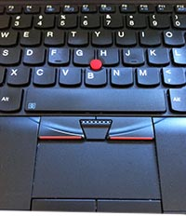
This laptop has a trackpad and a track stick (the red dot between the keys).
The trackpad is the solution to the problem of how to allow the users of laptops to work with a GUI without having to carry a mouse around with them.
The trackpad is a rectangular area below the keyboard on a laptop that senses when you touch it. As you move your finger on the trackpad the pointer moves on the screen.
Some trackpads have buttons below them that are the equivalent of the left and right buttons of the mouse. Other trackpads 'click' when you press or tap on them - and they do a 'right click' when you press on the bottom right (or some other user defined area) or tap with two fingers.
Trackpads have also adapted to allow you to use gestures to control your computer in the same way that you use gestures on a touchscreen.
Before the trackpad was invented laptops had a small button (usually placed between between keys on the keyboard) that could be used as a type of joystick.
This was called the track stick and pushing the button around allowed you to move the pointer on the screen. These are no longer popular and are seldom seen except on some models of laptops from
Lenovo
.
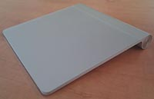
The Apple Magic Trackpad allows you to use a trackpad with a desktop computer.
It is possible to buy standalone trackpads for use with desktop computers - Apple specifically offers the 'Magic Trackpad' for their computers.
Some people feel that working with a large trackpad like this gives them more control than a mouse - and also allows them to use gestures with their desktop computer.
Back to the top of this Panel

Trackball
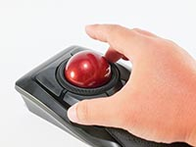
A trackball works like an old fashioned ball mouse. Except the ball is large, at the top and is rolled around by your fingers. As the ball moves so does the pointer on the screen.
Trackballs are great for workspaces where you don'y have a lot of space - the trackball device stays in one place.
Some people say that using a trackball is better for their wrists than a mouse is and swear that it reduces RSI.
Because of the ball design trackballs do have to be cleaned by removing the ball, cleaning it with a damp cloth and removing debris & dirt from the inside of the device.
Back to the top of this Panel
Digitising Tablet

The best way to draw by far
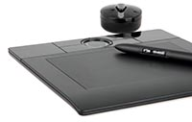
A digitising tablet allows you to draw on a tablet with a pen.
The tablet should not be confused with the type of computer called a tablet.
They may have the same name, but this type of tablet is a flat rectangle of plastic with a surface area that you can draw on with a special pen.
The area of the surface is mapped to your screen - this means that the top left corner of the tablet is the top left corner of your screen.
This mapping allows you to draw precisely - just like you would on paper.
The pens used are also pressure sensitive - so pressing harder will create a darker, thicker line.
Most of the newer tablets also allow for touch input (so they can be used as a trackpad).
Wacom
(the biggest name in digitising tablets) even sells digitising tablets that are a LCD screen - so that you draw directly on what you see.
To add to the confusion they do also sell digitising tablet computers that look and feel like more bulky tablet computers but are designed for drawing and art work.
Devices such as the
Microsoft Surface
tablet, laptop and desktop also have this type of technology built into them.
Using
Apple's Pencil with an iPad
gives the same type of precision and accuracy as a digitising tablet.
Back to the top of this Panel
Back to the top of the Dropdown List
Scanners & Cameras - capturing images, barcodes & QR codes

Images - our visual world…
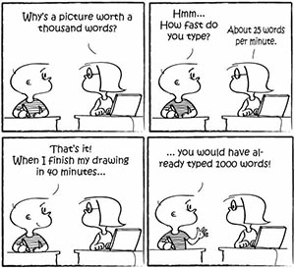
By Tryptofish [CC BY-SA 3.0 ], from Wikimedia Commons
It is said that a picture paints a thousand words…. (
feel free to give a groan at the cheesy clich.
Cliches aside, computing is a very visual experience. We depend on the screen for feedback on what we are doing. We use a GUI that is rich with icons and menu items for our interface. Thousands of hours and lots of cash is spent making sure that the interface of the apps we use is visually appealing and easy to understand / use.
Most of this visual feast involves graphics and photos.
In the past getting graphics onto a computing device was a major effort.
For photographs you had to:
take the photo,
have the film developed and pictures printed,
put the pictures into a scanner and scan the image into the computer.
Drawing graphics had to be done on low resolution screens with the mouse as a drawing device.
Today it is all much simpler. We get images / text into our computing devices using:
Digital cameras

The best camera is the one you have with you…
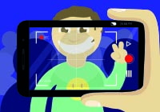
Think about it - something happens and you need to take a picture - quick!
In those circumstances
any
camera is better than
no
camera!
In this section we are not going to discuss or argue about which camera is better. Instead we will talk a little about what cameras are used for and then take a look at features that are important when buying a camera.
When thinking about digital cameras you need to think about much more than just taking pictures and recording videos though.
Digital cameras have become a major type of sensor input for computing devices.
They allow our machines to 'see' and give them the ability to do things like drive cars - and diagnose illnesses…
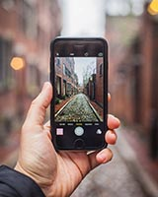

Smartphone cameras
Smartphone and tablets have two cameras, one on either side.
The front facing camera is used for video chats and selfies. `it is generally lower resolution than the back facing camera.
The rear camera is higher resolution.
Both cameras can be used for video - and many smartphone cameras are capable of slow motion (recording video at up to 240 frames a second) and even 4K (high resolution) video. In fact multiple full length movies have been made using nothing but iPhones! (check out a list from 2018 in Variety).
The smartphone camera is undeniably the one you have with you all the time - and its constant improvement and development in hardware and software combines with its convenience to cause a huge decline in point-and-shoot camera sales.
People tend to forget that your smartphone's camera can also be used to 'scan' documents instead of having to find a scanner and computer.
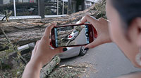

Smartphones cameras at work
Smartphone cameras have become an essential part of the workflow in many jobs. Plumbers, electricians, builders, police detectives, insurance assessors - in fact anyone who needs to make a record of anything - will use these cameras as part of their daily routine.
Use these cameras to document things (like when a tree falls on your car) - even take photos of receipts and other documents for record keeping purposes!
Smartphone Cameras
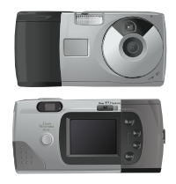

Point -and-shoot cameras
Point -and-shoot cameras are also known as compact cameras.
They are smaller than DSLR cameras, have a fixed lens and are much cheaper.
The biggest advantage a point-and-shoot camera has over a smartphone is a wider focal length - this means that you can zoom in and out.
Generally smartphone cameras only allow for digital zoom which decreases the quality of the image.
Point-and-shoot cameras have lenses that can provide optical zoom.
Point-and-shoot cameras are the middle of the road. They can be better than smartphone cameras (not all of them are) but they are not as good as DSLRs.
Their use and sales globally is in rapid decline because smartphones are more than just 'good enough' for most people - and these cameras add little value for the cost of having something extra to buy, carry, charge and look after.
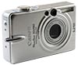
Point & Shoot Cameras
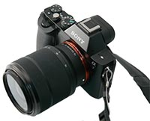

DSLRs
DSLR stands for Digital Single Lens Reflex. These are the cameras that are used by professional photographers and film / TV makers.
DSLRs produce much higher quality images, have lenses that be swapped out for the best quality images and are very expensive (the best DSLR bodies cost between R80 000 and R 100 000 - and then you have to buy lenses to use with the body. These lenses range in price from R15 000 to over R200 000 per lens).
Because of their larger physical sensors, DSLRs are much better at capturing images in low light conditions.
DSLRs are also capable of capturing high quality video - and are cheaper than specialised video cameras. They have been used in filming for TV and movies.
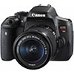
DSLR Cameras
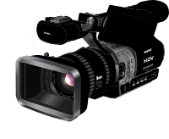

Video Cameras
Video cameras are designed for capturing video, not still images.
Compared to using a smartphone, point-and-shoot or DSLR to capture video, dedicated video cameras provide longer recording times, better control over focus and zooming, better sound input sources - and much more.
If you want to film a lot of video a separate camcorder or video camera makes sense because video takes up lots of storage and can easily fill up your mobile device's storage very quickly
All films and videos are edited on computer using software such as Adobe Premiere Pro, Avid or Apple's Final Cut Pro.
Some movies are still filmed on actual film stock and have to be captured using a scanner before they can be edited.
Video is used a lot in science, sports and medicine to record and analyse events and performances and to diagnose problems.
The video camera features of smartphones, tablets and webcams is used to enable video chats and video conference calls.
We are all familiar with special effects in movies but tend to believe news, interviews and other 'factual' videos. Be aware that a technology known as Deep Fakes makes it possible to put anyone's face onto another face - and make them seem to say things that they never said!
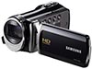
Video Cameras
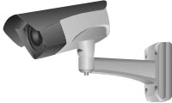

Security Cameras
Security cameras are digital video cameras
They are used to monitor the activity in controlled areas. Many cities around the world have installed thousands of cameras to help monitor the state of the city and to combat crime.
The cameras range from fixed, low resolution cheap cameras that just provide a general image to zoomable, movable, motion tracking cameras with super high resolution.
The cameras have their footage recorded, usually on hard drive, and are monitored by both people and computer algorithms to detect possible security breaches.
It is relatively cheap and easy to install a set of digital security cameras in your home - and most of them can be internet connected so that you can view them from anywhere you have a good internet connection.
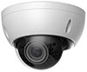
Security Cameras
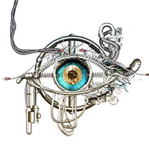

Letting technology 'see'
Digital camera technology has become so small and cheap that cameras can be built in to many devices.
Advances in image processing software allow these built in cameras to be used to 'sense' and interpret the environment and allow computer controlled equipment to operate with more precision and do things never before possible.
Some examples of computer vision / machine vision include:
Facial recognition - This is used in biometrics, tagging friends in social media, the security industry, police and military applications and much more.
Robot vision (allows robots to see / navigate their environment without human control (includes self-driving cars)
In industry computers can do quality control (something only people could do) by looking at products. Robots can also pick things up without the thing having to be a pre-specifies size and in a pre-specified position.
Object identification - It is possible (with limited success) to take a photo of something with your smartphone and have a powerful computer in the cloud identify what you are looking at.
Medicine- computers can identify tumours and growths in scans, control robots in surgery, enhance surgeon's visions - and much, much more.

Cameras as sensors - Computer Vision


Photo editing
Photo editing has been around almost since the first photograph was taken.
People 'fixed' and manufactured images by techniques ranging from double exposure to airbrushing photographic prints.
The difference is those techniques took a lot of time, equipment and expertise to master.
Today photo editing software such as Adobe Photoshop, Affinity Photo, Corel Photo-Paint and The Gimp allow anyone with a computer to magically (and almost undetectably) alter photos in record time.
The result: you can't always believe what you see and photos do lie.
In fact, in this time of fake news, it is best to be sceptical about photos (and videos) and check them for validity just as you would and text news article.
Worse than that, the use of photo editing of images of celebrities and models in magazines has created an unrealistic view of the perfect person (even these celebrities do not look like this, that's why the images are edited).

The camera never lies - NOT!
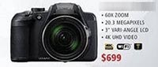

Camera specifications - explaining the technical terms…
When buying, choosing or using a digital cameras you are always faced with a lot of technical terms that try to explain the performance and abilities of the camera
We try to explain these terms as quickly and simply as possible below…
A Megapixel is a measurement of the number of pixels on a camera's image sensor - measures in 'millions of pixels' where 1 million pixels = 1 megapixel.
To calculate the 'megapixels' you take the number of horizontal pixels and multiply it by the number of vertical pixels.

What advantage does a higher megapixel count give you?
Well, obviously, your image will have a higher resolution. This means you can view it or create a larger print without seeing blockiness or jagged lines. Lines will be crisper and sharper, details clearer, etc.
A high megapixel count means that you can crop the image (zoom in to a smaller area) and still have a useable picture that will not be low resolution or lose too much detail.

Megapixel Calculator
Type in the size of any screen / picture / image sensor in pixels to show how many MegaPixels it has!
Horizontal Pixels:
px
Vertical Pixels:
px
[h-px] * [v-px]
No of MegaPixels:
.00
Mpx
[px] / 1000000

Megapixels

The top closeup is of low ISO and the bottom is of high ISO - you should see the noise in the bottom image.
Photo By HuttyMcphoo [GFDL, CC-BY-SA-3.0 or CC BY-SA 2.5 ], from Wikimedia Commons

Sensitivity to light
ISO is the ability to adjust the camera sensor's sensitivity to light.
You use a low ISO (e.g. 100) to capture an image when there is lots of light. You need a high ISO setting when there is low light (it is dim or dark).
Obviously, the higher a camera's possible ISO setting, the better it is able to capture an image in dim light without using a flash.
There is a problem though: Noise!
When you look at a picture that has been taken in low light with a high ISO setting you will see it looks grainy - splotched with large dots with clear red, green or blue dots showing up in the picture.
These dots are noise caused by trying to amplify the light too much (just like the scratching and hissing you get when turning the volume up too loud).
A larger physical camera sensor allows the individuals to be bigger and catch more light - making it better at capturing an image in low light with less noise.
A larger sensor generally gives a better overall image with more detail, better colour, etc.
Smartphones generally do not give you control over the ISO settings used when taking photos.
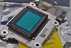
ISO & Sensor Size
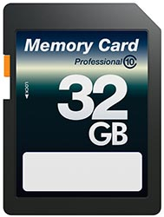
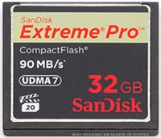
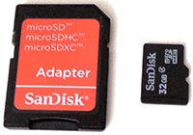

Memory cards
Digital cameras store their images on memory cards - except for smartphones where the image gets put into the devices storage.
There are many different kinds of memory cards but the ones used the most are SD cards, Micro SD cards and Compact Flash cards.
These cards range in size from a few Gb to a few hundred Gb. Obviously higher capacity = higher speed.
High end DSLRs tend to use Compact Flash because it delivers faster performance.
The capacity of the card (how many gigabytes it can hold) is not the full story though. Tied to the capacity of your storage is the way the camera saves its photos.
Jpeg
You can set your camera to save images in the Jpeg format. This means the camera compresses the image data before saving it to storage. This results in a smaller image file - and so you can fit more images on the same sized storage.
RAW
If you set your camera to save RAW files it is saving the pure data from the sensor without doing any processing or compression.
This means that each image file will be much larger (you will be able to fit less of them on the same size storage).
BUT - the image data is much more detailed and allows for much more scope in editing and correcting errors.
Professional photographers almost always shoot in RAW.
Most smartphones do not give you the option - all images are stored as Jpegs.

Transferring images
Although it is possible to connect your camera to your computer using USB this is slow and can drain your camera's battery pretty quickly.
A far better solution is to get a card reader, take your card out of the camera and plug it into the card reader. Then connect the card reader to the computer.
The computer will see your cameras card as external storage and you will be able to copy and delete files using the file manager!
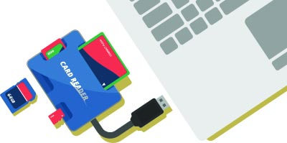

Storage & Image format
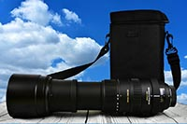
A zoom lens for a DSLR.
Photo Maxpixel.net

Getting closer to your subject
Digital cameras offer two kinds of zoom:
Digital zoom
Digital zoom is the same as zooming in on a picture displayed on your screen. Sure, the area you are interested in gets bigger, but it also becomes more blocky and pixelated.
The camera takes an area of the sensor and saves that area as the whole image - enlarging it to fit the whole picture area.
Digital zoom always reduces picture quality and should be avoided if at all possible.
On smartphones you don't really have an option because they don't have the space for real zoom lenses (yet - there is some interesting technology which might make this possible in future).
Optical zoom
Optical zoom is when you have a lens that changes how the image falls on the sensor - the lens either magnifies or thinks the image area.
The sensor uses its whole area to capture the image.
The result is a much higher quality image.
Zoom lenses are large, heavy and expensive - good quality zoom lenses for DSLRs cost well over R100 000.
Zooming in and out is one of the big advantages that point-and-shoot cameras and DSLRs have over smartphone cameras.
When using a smartphone you simply have to zoom with your feet (walk closer to what you want to get a closeup of)!

Zoom
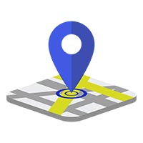

WifI
WiFi is another way to transfer images from your camera to your computer. It can be useful but, like connecting your camera to your computer, it can drain your camera battery quite quickly.

GPS
Your smartphone has a GPS built in - that means that photos that you take with your smartphone are geotagged (the attitude and longitude co-ordinates of where the photo was taken are recorded in the photo file).
Remember this when you post photos anywhere - anyone who looks at the image metadata (the extra data in the photo file that is not part of the photo) can see where you were when the photo was taken.
Some point-and-shoot / DSLR cameras have GPS built in too - and some allow you to buy an add on dongle that adds GPS to the camera as well.
Geotagging is how software 'magically' can show you all the photos you have taken in a specific place or area.
Geotagging is also particularly useful for documenting things and for field workers, researchers etc.

Communications & GPS
Back to the top of this Panel
QR codes & Scanners

Magical payments, web pages, etc…
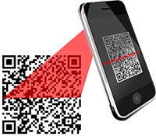
The QR (Quick Response) code is a two dimensional barcode that can hold much more data than a conventional barcode.
QR codes are used for all sorts of purposes - but as consumers you are most likely to find it:
in advertising - as a quick way to connect to a web site
as a quick payment method connected to an app on your phone (e.g. Snapscan or Zapper)

Scanning / 'Reading' a QR code

To scan or 'read' a QR code you typically use your smartphone camera.
If your model of smartphone does not automatically read a QR code in camera mode then you will need to download and install a QR Reader app (there are many and they are usually free).
Either start the camera or the QR Reader app, point the phone camera at the code and that's it.
The information in the QR code will be displayed - and if it is a link to a web site you will have the option to open the site in your browser.
If the QR code is for payment then you need to open the appropriate payment app and use that to scan the code.
You can even scan QR codes from your screen - try scan the one on the right and see what it says….


Creating a QR code
Creating a QR code is not complicated or difficult. You don't even need special software.
There are many sites on the web that will let you create a QR code and download the resulting image.
The QR Code Generator
is one of them.
These sites will all try to convince you to create an account and pay for the service - this is for people who need extra features such as adding logos and colour to the code, etc.
It is not necessary to sign up to create a basic QR Code.
Just type in your text, the code will be generated and then save the image to your computer.
That's it - you now have a QR Code that you can include in a document, poster, presentation (or even as a way of sending messages to people).
This type of web site is an example of an interactive web application.
Back to the top of this Panel
Barcodes and barcode scanners

Barcodes - essential for Commerce & Shipping
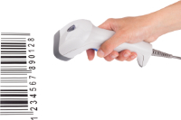
The barcode is a number presented in a pattern of lines that can be quickly, easily and accurately scanned.
There are many barcode formats / standards.You do not need to know about them.
Barcodes are printed the packaging of almost every product produced today. They are also printed and used on everything from mail and parcels to items that you want to keep track of - e.g. the computers in your school.
Barcodes are an essential part of POS systems. They are used to scan items at the till and so speed up the whole check-out process at whatever shop you are in.
Remember: The barcode itself contains nothing more than a number. This number is scanned and then looked up in a database.
The database supplies extra information such as the price of the item and the number of items in stock. Or, if it is a letter / parcel - the name of the sender, the name and address of the recipient and the date the item was posted.
Back to the top of this Panel
Picture & Document scanners & OCR

Getting documents and images onto the computer
Not so long ago a scanner was the only way to get an image or a document onto the computer.
Today most consumers don't bother with a scanner - they just use their smartphone camera to take a photo of that document or photo that you need to 'scan'.
BUT: scanners still have a place.
A properly used scanner will create a better image than a smartphone - especially if the smartphone is handheld and the light is bad. So, when quality matters a scanner is better.
Automatic sheet fed document scanners used in business can scan long multi-page documents automatically and combine all the pages into a single .pdf file.
Multifunction printers include a scanner which allows them to not only scan pictures or documents but also to make photo copies - and if they have the feature built in, to send the scan as a fax or email.
No matter whether you use a scanner or a camera, the result is still an image - a picture.
This is great when you are trying to get a photo or drawing onto the computer. It's not so great when you want to get a document onto the computer so that you can edit it. (Hint, you can't edit text in a photo).

OCR
This is where OCR (Optical Character Recognition) comes into the picture (pun intended).
OCR is software that takes an image and identifies the writing in it and then converts that writing into text.
Good OCR software will even try to keep the layout, font and formatting of the original text
When the conversion is done the OCR software saves the result into a file that you can open and edit - again, good OCR software supports many file formats so that you can save the file for use with your favourite software.
Your scanner usually comes with some form of OCR software. More advanced OCR software can be bought - or you can even use the OCR feature built into Google docs (see the video links for more).
Back to the top of this Panel
Back to the top of the Dropdown List
RFID & NFC

A different type of 'scanning'…
RFID
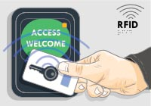
RFID can be used for security as well as tracking goods and payments.

RFID is used to trace the owners of lost animals.
RFID stands for Radio Frequency Identification.
Think about driving on the highway and getting to a toll plaza.There's always a lane for cars with e-tags. These drivers don't have to stop and pay, they just drive through and the boom gate opens to let them pass.
How does this work?
These cars have a e-tag device in them. This device contains a small microchip that can store data such as the user's identity and bank details / e-tag account, e-tag balance, etc. The microchip is connected to a radio antenna. The device does NOT have a battery.
When the driver drives into the toll gantry a powerful radio antenna communicates with the microchip. The electromagnetic field from this radio causes the antenna on the e-tag device to generate its own power through a process known as induction. The microchip now has power and communicates with the toll gantry, giving it the payment details to let the car through.
When the car gets out of range of the radio in the gantry the microchip loses power and is switched off.
What has just been described is a passive RFID chip at work.
An active RFID chip includes a battery for power so that it is able to transmit over longer distances.
NB: The communication for RFID is one way - the microchip sends data to the receiver.
Technically, RFID is a system used by devices that connect by radio to communicate with each other. The technology is what allows any and all WiFi devices to have a unique identity (including cell phones, WiFi routers, Bluetooth devices, etc.).
Nobody (except an RFID techie boasting about the value and importance of RFID) thinks of RFID this way. Everyone thinks of RFID in terms of the e-tag example above.
RFID is used for all sorts of things:
You are using RFID if you 'microchip' your pet (if the pet wanders off and gets found by someone else the vet scans for the chip. The chip contains a number like a barcode. The number is looked up in a database and your contact details are displayed so that you can be called to come and fetch your pet).
RFID is used to track parcels during shipping.
RFID is used to track and monitor products as they make their way through the manufacturing process.
RFID is used for fast payment at toll gates on highways
And much more
Back to the top of this Panel
NFC
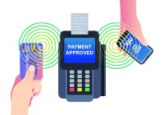
NFC is commonly used for contactless payments.
NFC stands for Near Field Communications.
NFC is a type of RFID where the strength of the radio communications is reduced so that the devices have to be very close to each other to be able to communicate (almost touching, at most 1cm or 2 cm apart).
The technology also allows for the chip to include processing functions - and for the communication to be 2 way (the chip can send and receive data).
NFC is the preferred method of doing contactless (sometimes called cardless) payments - when you tap your card (or phone) to pay. It is preferred because its short range makes it harder to hack from a distance.
NFC can be used for other purposes as well and you can even program your own functions into cheap NFC tags that you can buy.
If you want to use NFC then it is better to buy and use an Android phone because Apple restricts the use of NFC in its iPhones.
Back to the top of this Panel
Back to the top of the Dropdown List
Touchscreens - using the screen for input

Input when your device is nothing but screen
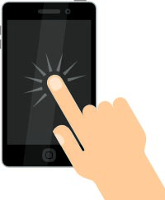
The smartphone and tablet as we know them today are nothing but slabs of glass. They have very few physical buttons, no keyboard or mouse.
This design is made possible by the invention of the touch screen - and enhanced by the development of multi-touch.
With a touchscreen there is no pointer on the screen - and your pointing device is your finger.
A click is a 'tap', a right click is a long press of your finger. A drag is intuitive.
Typing on a touchscreen is done using an on screen keyboard.
As soon as a field requiring text input appears on the screen, so does the keyboard.
The big disadvantage of an on screen keyboard is that it takes up a large amount of screen space - reducing the useable area of the screen.
For this reason many tablet users buy cases or external keyboards that they can use instead of the on screen keyboard (especially if they use the tablet to create or edit content).
Touchscreens also allow the use of gestures
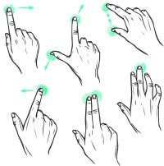

Gestures
The gestures your device accepts and understands depends on the OS - but the common ones are:
Swipe - used to scroll, turn pages, etc.
Two fingers Pinch - used to zoom out
Two fingers Push apart - used to zoom in
Check out the video links for more gestures!
Back to the top of the Dropdown List
Sensors - Input without people

Automatic data collection
A huge trend in computing is for devices to try to be aware of themselves and their surroundings.
This data is collected by sensors that constantly feed the device with input without any human interaction.
For example your smartphone knows:
Its orientation - whether it is being held vertically or horizontally (sensor: Gyroscope)
If it is angled or tilted in any way (sensors : Gyroscope & Accelerometer)
If it is moving (sensor: Accelerometer)
The direction it is facing - North, South, etc. (sensor Compass)
Where it is on the surface of the earth (technology: GPS assisted by WiFi database - can be accurate to within 2m)
Its temperature - so it can power down if it gets too hot (sensor Thermometer)
How bright the light is (sensor Light sensor - used to adjust the brightness of the screen, change the colour of the screen, etc)
How close it is to your body (sensor Infrared proximity - used to disable the screen during phone calls so that you can't accidentally give input with your ear)
Its height above sea level (sensor Barometric altimeter - measures air pressure combined with GPS)
The sound being made around it (sensor Microphone - this is only true when your digital assistant is set to be always listening; the device is then constantly checking for the command phrase used to activate the digital assistant)
The camera is also a sensor but this is only on when you turn it on to take photos or record video.
You don't give it any of this information. Instead it collects all the information from sensors.
It uses this sensor information all the time - to change the layout of the screen, to dim or brighten (or even change the colour) of the screen, etc., etc.
The increasing (and intelligent) use of sensors is made possible because sensors have been miniaturised and require very little power.
The trend created by sensors is for computing devices to be more aware, respond to their environment automatically and to anticipate our needs by drawing on information they detect without us telling them about it
Sensors are also a faster, more accurate way for computers to collect data without having to rely on slow, mistake making humans to enter that data.
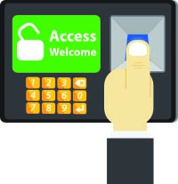

Biometrics
Biometrics is measuring biological features of people such as the pattern of your fingerprint or the iris of your eye, the shape of your face or the sound of your voice.
These features are unique to each individual and so can be used as part of security as the best way to identify you and make sure that you are really 'you'.
Biometric security is used extensively in mobile devices (smartphones, tablets and some laptops) but is not really a feature of desktop computers.
These mobile devices include built in fingerprint scanners or facial recognition cameras (and software).
Biometric input is also used for access control to buildings and secure areas.
Back to the top of the Dropdown List
Input for Gamers

Natural controls for games
Right from the start gamers wanted more natural feeling controls for their games than pressing keys on the keyboard (and then later using the mouse and the keyboard).
The first dedicated gaming control was the joystick.
Home gaming consoles developed their own customised controllers and later specific controllers such as steering wheel, pedals and gearshift (for car racing games) and movement trackers such as Microsoft's Kinect and the Wii controllers were also developed.
Joystick

For flying, man….
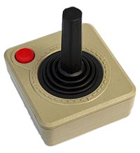
Photo By Bilby [CC BY 3.0 ], from Wikimedia Commons
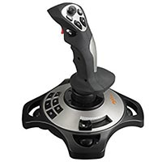
By Johni006 [CC BY-SA 4.0 ], from Wikimedia Commons
The joystick was the first dedicated game controller.
It was found in arcade games, home consoles and even the first personal computers (we're talking the ZX Spectrum, Commodore 64, etc.) had joysticks that you could buy and use with the games that you played.
The first joysticks were basic in shape and design, has one or two keys and were meant to be used with any type of game.
Todays joysticks are more sophisticated, have multiple buttons and are meant to be used with flight simulators or aerial combat games.
In fact, dedicated flight simulator fans buy a flight control set with joystick, throttle and rudder pedals to make their experience feel as close to piloting a plane as possible.
Force feedback (haptics)
To enhance realism some joysticks have motors in them that cause them to push back against you when you are doing high G-force manoeuvres just like real plane controls would.
Strictly speaking this type of joystick would qualify as a dual purpose input-output device.
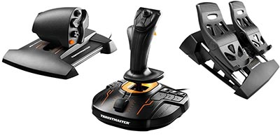
Back to the top of this Panel
Steering wheel

Better control on the road
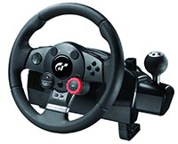
It's difficult to drive well using anything but a steering wheel.
Keyboard and mouse, console controllers, joysticks - nothing really feels right!
That's why racing / driving game fans prefer to use a driving wheel controller.
Just like for flight simulators, dedicated driving gamers go the whole hog and get a set with steering wheel, gear shift and pedals for accelerator, clutch and brakes.
Force feedback (haptics)
To enhance realism some driving wheels have motors in them that cause them to push back against you when you are doing high G-force manoeuvres just like a real car steering wheel would.
Strictly speaking this type of driving wheel would qualify as a dual purpose input-output device.
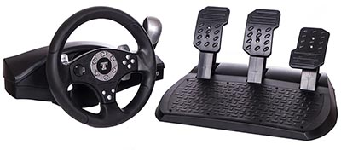
Back to the top of this Panel
Console Controllers

Multi-purpose game controllers
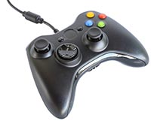
Console controllers have multiple triggers and buttons. They are meant to be held in both hands and are used for all sorts of games from platformers and driving games to Real Time Strategy and First Person Shooters.
They are supplied along with gaming consoles such as the Xbox and Playstation range.
They are usually wireless and connect to the console using bluetooth.
With a little bit of work it is possible to connect these controllers to (and use them with) games on your computer.
Back to the top of this Panel
Movement tracking
For a while movement tracking input such as the controllers used with the Wii as well as the Kinect and Playstation Move were very popular.
These controllers have fallen out of favour. The Wii is no more and Microsoft has even stopped making the Kinect.
This type of controller is still being developed for VR.
Back to the top of this Panel
Back to the top of the Dropdown List
Input for the disabled

Making computers accessible to everyone
Try to imagine wanting to use a computer if you are blind, paralysed or deaf.
Scary, isn't it?
Computing devices are designed for the majority of us and little attention is paid to people who can't do what everyone else can.
Disabled people find themselves on the wrong side of the digital divide. Such a person may live in an area where technology is available - and be lucky enough to afford the technology - but the physical design of devices make it difficult or impossible for them to use.
There are two ways that computers are made more accessible to people with disabilities:
Through the accessibility features of the OS
Through custom hardware and software
If you look in the Control Centre (Windows) or System Preferences (Mac) you will find the
Accessibility option. Using this you will be able to turn on and configure features such as:
Screen reader:
A text-to-speech system to read what's on the screen. For blind or visually impaired users.
Magnifier:
Helps users with visual impairment who need larger text and images
High-contrast mode:
Helps users who have trouble seeing text unless contrast is corrected, such as white text on a black background, or vice versa
Mouse keys:
Controls the mouse using the number pad / arrow keys.
This is for users with problems with fine motor control who may be shaking too much to control a mouse.
This is also useful for situations where your wireless mouse batteries run flat and you don't have replacements on hand.
Can usually be activated by a sequence of keypresses
Sticky keys:
Helps users who have trouble pressing multiple keys at once, and users who have use of only one hand.
Usually activates automatically if you press the same key repeatedly - e.g. press shift multiple times and you might activate sticky keys.
The OS then acts as if you are still holding the shift key down when you press the next key on the keyboard.
Bounce keys:
To ignore rapidly pressed keys or if a key is accidentally held down. This is for users who have problems with fine motor control - they don't move quickly enough so what should be a single key press is too long.
On screen keyboard:
Helps users who cannot type at all, but who can use a mouse, eye tracking, head tracking or sip-and-puff input devices to control a pointer.
Visual alerts:
Replace system sounds with visual cues (flashing notices on the screen - for deaf or hearing impaired users).

Customised hardware
There are customised hardware solutions that can also help people use computers, for example:
Braille keyboard

Computing for the Blind
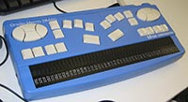
Photo by Kazuhito Kidachi from Flikr
There are two ways that a blind person can interact with a computing device, namelysound andtouch.
Screen reader software reads all the text on the screen - this includes menu options, icon descriptions, the alt text for images on web pages, etc. This is how most blind people 'see' a computer.
But they also have to provide a computer with input.
Sure, they can talk to the computer but voice recognition is not 100% accurate and can be frustrating. Besides, typing is still the fastest way to input text.
You design a special keyboard that relies on a blind person's heightened sense of touch - using the standard raised dot pattern alphabet known as Braille.
A Braille keyboard is a two in one device.
It combines a braille display (the bottom row) with inputs that allow a blind person to read and write braille with a single device.
Back to the top of this Panel
Eye / head tracker

For when you can't move your arms or hands
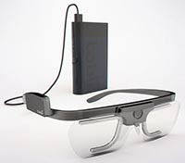
Eye tracking in wearable glasses.
Photo By Tobii Technology [CC BY 3.0 ], via Wikimedia Commons
This is hardware that tracks the movement of your eyes (or even software that uses your computer's webcam to track the movement of your head).
Your eye / head movement moves the mouse pointer on the screen.
A slow blink (or in some cases keeping the pointer still in a spot) is like clicking.
Typing is done by displaying an on screen keyboard and clicking on the keys.
This hardware comes in different forms from cameras positioned above or below the screen - to wearable glasses.
Versions of this hardware are also being marketed as a different type of game controller - specifically for FPS gamers.
Back to the top of this Panel
Voice / Speech Recognition

Speak and be heard
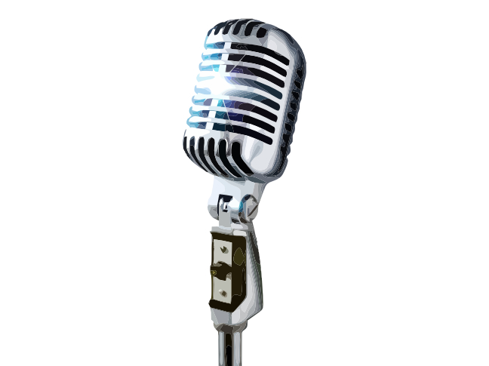
Another way of controlling a computer and providing input for everyone (not only the disabled) is to use voice recognition technology.
The only hardware you need is a good microphone (the built in microphone for laptops is usually not good enough and desktop computers usually don't have a microphone).
With voice recognition you speak to the device and it converts the sound of your voice into text. The software then either interprets the text as a command - or takes it as text input.
People are used to talking to their devices to use voice activated assistants such as
Siri
,
Alexa
Cortana
or
Google assistant
.
Desktop and laptop OSs do include voice control features (also in the
Ease of Access section of Control Panel
(Windows) or the
Accessibility section of System Preferences
(Mac)).
Dedicated voice control software for both systems is provided by a company called
Nuance
.
Voice recognition has made dramatic advances in the past few years but is still far from perfect (think of your interactions with the voice activated assistant on your device).
Accuracy can be increased by training the software to recognise your voice - but be aware that you will always need to proofread text dictated to a computing device to find and remove the inevitable errors.
Back to the top of this Panel
Back to the top of the Dropdown List
Input for Mobile Devices
As you should have understood if you read through the other sections, mobile devices get input from:
Touchscreens
Sensors
Microphone
Camera
Wireless communications (Wifi, Bluetooth, Cellular)
Radio devices such as GPS, RFID / NFC, etc.
Besides these default input methods, various input devices can be connected using Bluetooth or USB - this includes keyboards, microphones etc.
Back to the top of the Dropdown List
Ergonomics
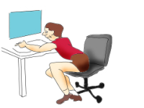

Human centred design
Ergonomics is all about making out environment and tools better fit to our bodies to minimise the harm they do us and increase our comfort.
IT is not the only area of human activity that ergonomics is applied to.
You may not know it but many things about using IT can be bad for you - from the way you sit, the way you type and use your mouse and the way you type on your smartphone with your thumbs to the amount of time time you spend staring at the screen.
Bad work and usage practices can damage your health.
Some of the problems that can arise include:
RSI

Too much of anything is bad…
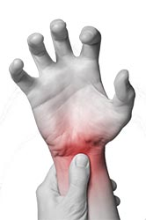
RSI stands for Repetitive Strain Injury.
You get it from repeated movements of a joint or body part.
Examples of RSI include:
Carpal Tunnel Syndrome
This is where your wrist becomes extremely painful and your hand can become numb, suffer from pins and needles and not want to move or respond properly.
You can get it from using your mouse or keyboard incorrectly, the incorrect posture whilst working or a combination of both.
I have suffered from CTS and I can tell you that it is not pleasant. I have recovered by wearing a wrist brace and by using a vertical mouse.
CTS is not limited to computer users - you can get it from playing musical instruments (especially the piano), assembly line work, sewing - in short, anything where you do repetitive movements of your wrist.
Ergonomic keyboards and mouses are designed to help fight this condition.
Smartphone Thumb
This is a problem for people who spend too much time typing on their smartphones using their thumbs. This is a type of tendonitis that causes painful, arthritic thumbs from overuse in unnatural positions.
Tennis Elbow and others - RSI is not limited to IT workers but to anyone who does small repetitive movements.
Prevention
Don't work / play for long uninterrupted periods of time. Stop, get up and move around for at least 5 minutes every 20 - 30 minutes.
Try to arrange your workspace ergonomically - and use ergonomic input devices.
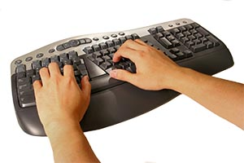
An ergonomic keyboard is designed to let you hold your wrists in a more natural position, reducing the strain on your tendons and preventing CTS.
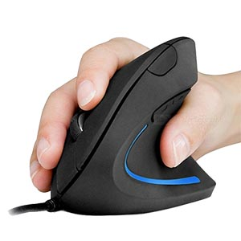
A vertical mouse is the best type of ergonomic mouse. Instead of twisting your wrist to lay your hand upon a horizontal mouse, the vertical mouse lets you keep your hand in a more natural 'handshake' position. This relieves a lot of stress on the tendons and helps prevent and reduce CTS.
Back to the top of this Panel
Computer Vision Syndrome

Don't stare…
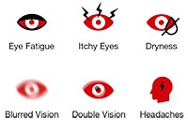
Computer Vision Syndrome is a condition caused by staring at the screen for too long.
It has many symptoms including :
dry, irritable eyes
blurry vision
problems refocussing the eyes after working on the computing device
headaches
eye strain
double vision
neck strain
Prevention
The best way to prevent this condition is to:
not look at the screen too long
remember to blink (seriously)
get up and move around and look away from the screen every 20 - 30 minutes
Back to the top of this Panel
Obesity

MOVE!!!

A direct consequence of working with IT is a sedentary lifestyle.
Computer users generally spend most of their day sitting. Sitting is bad for you.
Studies have proven that sitting causes weight gain and can lead to high blood pressure, insulin resistance and diabetes - all of which are potentially life threatening conditions.
For a while, standing desks were promoted as the solution, but it turns out that standing all day isn't so great either.
Recommended prevention is to move every 20 - 30 minutes.
Simply stop what you are doing, stand up, walk around and get away from the computer for 5 - 10 minutes.
Set an alarm or a timer to help you do this.
Back to the top of this Panel
Posture problems

Sit Correctly!
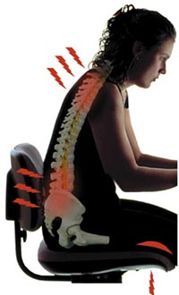
Photo By Skoivuma [CC BY 3.0 ], from Wikimedia Commons
A large part of ergonomics is making sure your workplace is properly configured.
This means matching the right chair to the right table, getting your keyboard and screen in the right position, etc. - all so that you have the right posture when sitting and working.
Bad posture can cause back pain, neck and shoulder pain and headaches.
In the long term it can cause musculoskeletal disorders, a permanently hunched or stooped position of the back and shoulders and lasting back and neck pain.
Solutions are to position things right, use a good chair, use the correct posture and take frequent breaks!
Back to the top of this Panel
Back to the top of the Dropdown List

Video Links - Keyboards & Pointing Devices
We have selected and curated a set of videos on YouTube related to your course.
These videos are not created or owned by us.
They may display advertising and in some cases may contain limited amounts of swearing.

Video Links - Cameras, Scanners, OCR, etc.

Video Links - RFID & NFC

Video Links - Biometrics
We have selected and curated a set of videos on YouTube related to your course.
These videos are not created or owned by us.
They may display advertising and in some cases may contain limited amounts of swearing.

Video Links - Sensors & GPS

Video Links - Accessibility for the disabled

Video Links - Ergonomics
We have selected and curated a set of videos on YouTube related to your course.
These videos are not created or owned by us.
They may display advertising and in some cases may contain limited amounts of swearing.

Notes for this Module
What to look out for and do in this module...

FAQs for this module
Questions on Hardware - Input and their answers...

Network Types FAQ
View the questions or type in the term you are looking for below…
No results were found

What is the most commonly used input device?
The answer used to be the keyboard but it is now the touchscreen.
The answer is still the Keyboard and mouse for desktop / laptop computers.

How do blind people provide input?
They use Braille keyboards - or use technologies such as voice recognition.

How do paralysed / quadriplegic people provide input?
There are various technologies -
- head tracking,
- eye tracking,
- speech recognition and
- sip-and-puff
input are some of them.

Can a computer get input without people being involved?
Yes.
The three main technologies involved are:
- sensors,
- data storage and
- data communications.

Can computers affect your health?
Yes.
Using many input devices makes you do small movements of your hands very frequently. This leads to a type of injury called RSI (Repetitive Strain Injury) which causes sore, inflamed wrists or thumbs.
Screens can cause eye-strain.
Sitting too long is bad for your health and general inactivity leads to obesity.
How you sit (and how your equipment is positioned) can also cause hunching posture and sore backs and shoulders.

